**CDAC Feb 2015**

**LAB 4**

Q1. Sequence Detector

Name: Bhrigu Bhargava

PRN: 150240133004

**Sequence Detector**

# Design Approach:

To begin with, the design is done using behavioural style of coding. Also, state machine is used to define the desired states.

1. Mealy Non-Overlapping: In Non-Overlapping, the state machine will return back to the idle state after the sequence is detected.
2. Mealy Overlapping: In overlapping, the state machine will return to some intermediated state other than the idle state.

**Synthesis:**

1. RTL Schematic

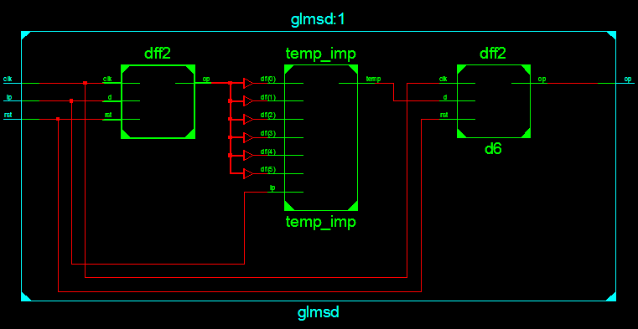

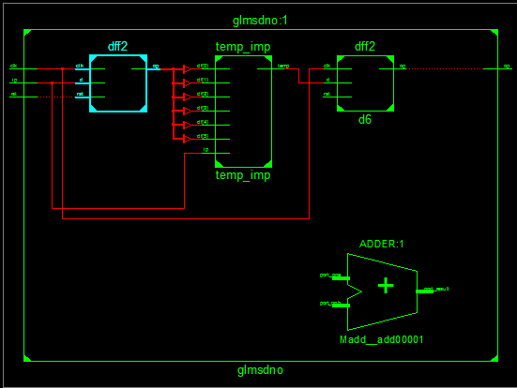

1. Block Diagram

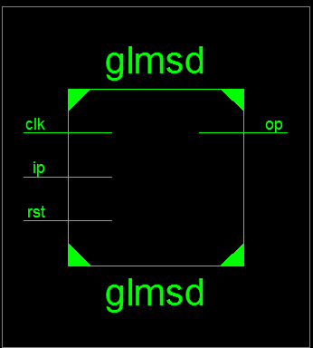

1. Tech Schematic

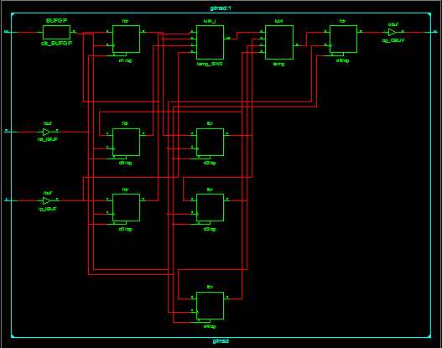

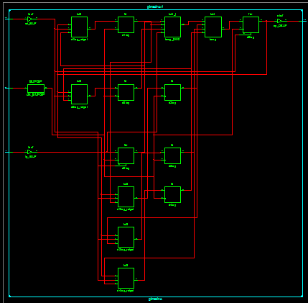

1. Simulation Waveform Result

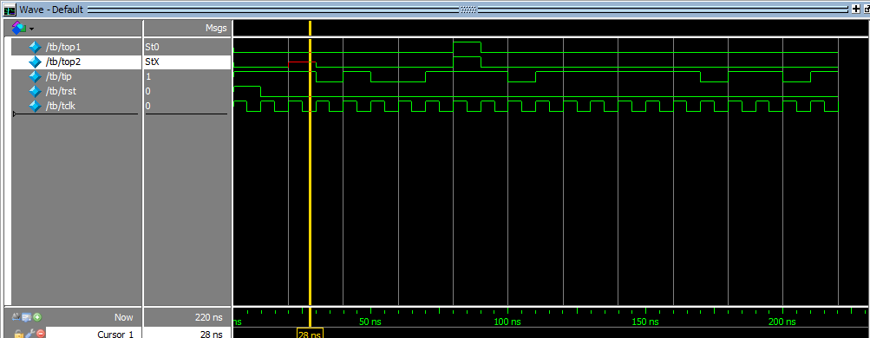

**Error:**

None

**Verified by:**

Dharamvir Chundawat (150240133007)